A. Explain how the code works for the program you submitted in Task 2.
First I used import pandas and then loaded the dataframe so we can use it and then I displayed the columns to check to see it imported successfully. The code then checks for rows total long term debt and total revenue if it exists. The code then calculates the debt to income ratio by adding a column that said debt to income ratio and the formula for that would be total long term debt/ total revenue. The code handles division by zero by recognizing if total revenue is zero for any row, then it will set debt to income ratio to NaN for that row and not include it in anything. The code then concatenates the original dataframe with the new debt to income ratio dataframe column and then it will store the new data frame combined called df_combined. Lastly the code makes sure it has worked out by displayed the combined dataframe to make sure it is accurate and correct and it did work out so the whole code for the programs works without errors.

B. Provide 4 customized data visualizations.
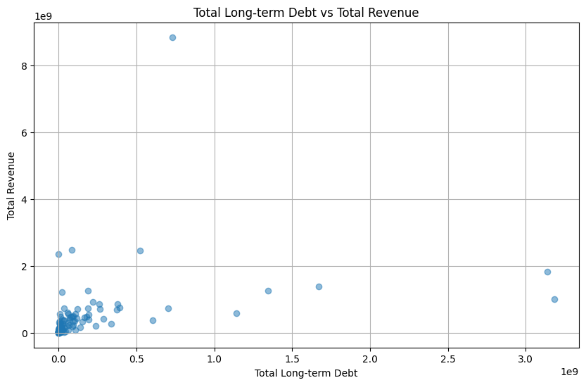
I wrote a program that compares total long term debt to total revenue, each dot represent a business ID
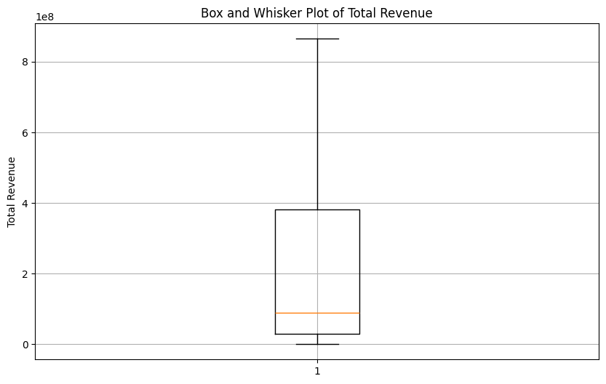
This shows the total box and whisker plot of total revenue
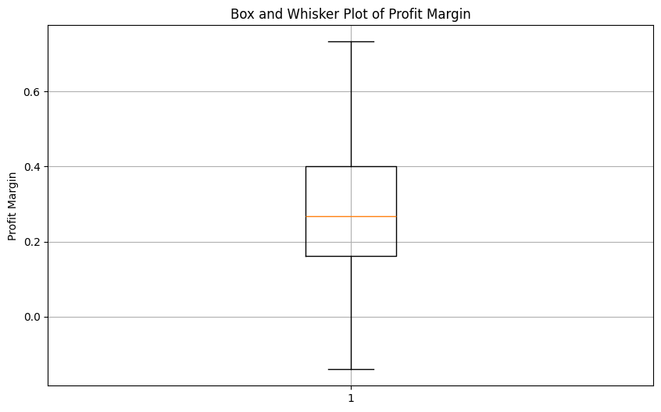
This shows the total box and whisker plot of Profit Margin

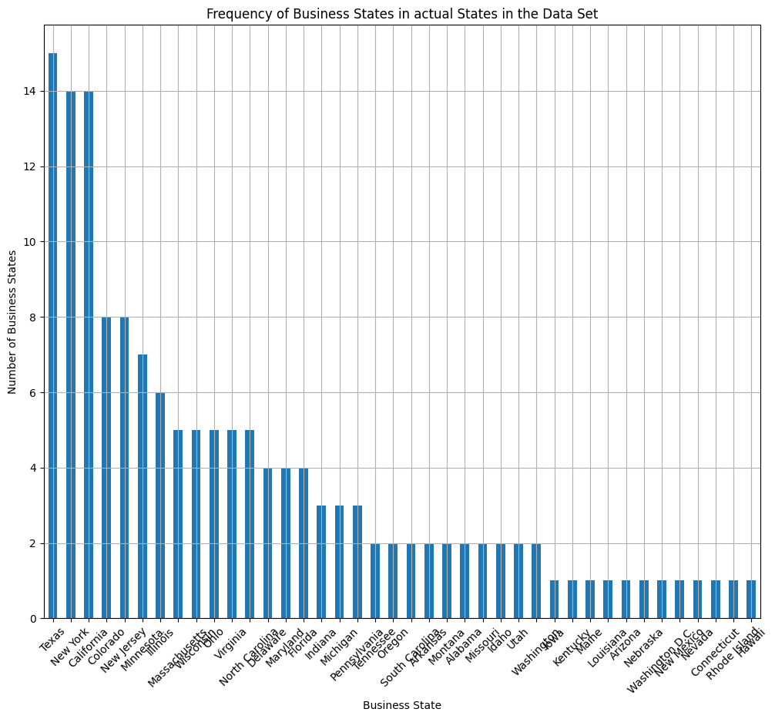
This graph shows the total number of time each business state that appears as a frequency.
C. Explain how customized visualizations in part B were created.

D. Acknowledge sources, using in-text citations and references, for content that is quoted, paraphrased, or summarized.

E. Demonstrate professional communication in the content and presentation of your submission.

